

2026 NEWSLETTER

Anderson Genetics – Driving Industry Success
2026 Ram Sale
Wednesday 21st October 12.30pm WST
(On display from 10am)
174 rams on offer On-property &

Full ASBVs & Genomic values
Lunch and refreshments provided
Find sale catalogues at www.andersonrams.com.au or on MERINOSELECT

All rams are non-mulesed and
paddock run
Interstate ram transport easily arranged with Falls Transport. PH: Lockie Falls 0429 82634

Property address for google maps is:

839 Anderson Rd Boilup 6394

So many studs and commercial breeders across Australia are benefiting from the potency of Anderson genetics. Independent sire evaluation trials across the country are confirming what our clients are seeing on the ground: industry-leading early growth, carcase and welfare traits, combined with productive, fine, high-quality wool. Anderson genetics deliver on all the major profit drivers.

Resilience doesn’t matter much when sheep run under perfect conditions - abundant green feed, low stocking rates and high management inputs. But real-world farming rarely operates under perfect conditions.

“Resilience” might be the new buzz word, but resilience and robustness have been central to our breeding objective for over 60 years.

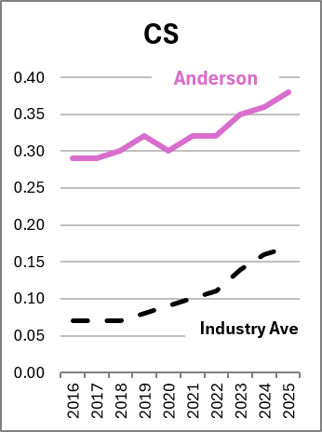
Long before we could measure eye muscle depth, fat, worm egg counts or condition score - and decades before Australia had Sheep Breeding Values (ASBVs) - we were annually culling ewes that failed to maintain body condition relative to their mob, regardless of how many lambs they had reared. With limited information, that disciplined selection built a deep-seated robustness and the ability to perform under challenging conditions.

What does that look like in practice?
- Ewes that hold condition and are more likely to conceive when feed is tight.
- Sheep that are naturally resistant to parasites, stay healthier and need fewer drenches.
- Low-dag, plain-bodied sheep that are easier to manage and less susceptible to flystrike.
- Wool with higher staple strength that attracts a premium.
Ewe pre-mating condition score and worm resistance ASBVs are good indicators of resilience

We’re not breeding sheep for ideal conditions – we’re breeding sheep for the conditions you farm in.


@lynleykoj
info@andersonrams.com.au
Anderson Rams
Ewe pre-mating condition score and worm resistance ASBVs are good indicators of resilience

2026 Sale Team
We are pleased to offer 174 rams for sale this year, again with many outstanding trait leaders among them.
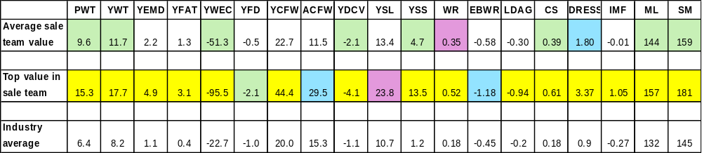

top 1% | top 5% | top 10% | top 20% | of values in Merinoselect
Flock rams will be available for private selection after the sale. For large enquiries please advise Lynley prior to the sale.

Online Auction

The online auction held in conjunction with the on-property sale will be run by StockLive.

admin@stocklive.com.au support 1300 259 742
If you intend to bid online, please register well ahead of the ram sale on the 21st October.

If you would like an agent or independent person present at the sale to bid on your behalf it can easily be arranged. Contact Lynley Anderson info@andersonrams.com.au 0429 328 055, or Troy Hornby, Nutrien Livestock, Kojonup on 0438 311 163.

Sale ram photos and videos will be on StockLive about two weeks before the sale.

Additional Sale Info

Special Prize Draws!!

Thanks to the generous support of Xytovet, four lucky commercial buyers in the shed will each win a Flock Profile Test, valued at $710 each. The test provides a clear snapshot of the genetic merit of your Merino ewe base, helping you better understand the strengths of your flock.
Shearwell have also kindly donated a voucher for 200 Sheep eID tags and a Speedy Tagger, valued at over $550, which will be won by one lucky commercial ram buyer in the shed.

Semen Rights: All rams are sold with 100% semen rights retained by Anderson Rams unless otherwise negotiated prior to sale.
Rebate Offer for Agents: Outside agents who provide written notice 24 hours before the sale - and attend in person to purchase rams for clients - are eligible for a 2% rebate. Please direct your notifications to either:
Mitchell Crosby, Nutrien Livestock at 0438 918 992 or mitchell.crosby@nutrien.com.au, or
Lynley Anderson on 0429 328 055
info@andersonrams.com.au
Pre-Sale Inspection: Interested in inspecting the sale team before the event? Simply contact Lynley for arrangements.

Accelerate Flock Growth with Anderson Genetics

Ewe Lambs Joined at 7 Months, Lambed at 12 months
Anderson ewe lambs have been successfully joined at seven months of age for many years, demonstrating the value of selecting for early growth, fertility and resilience. Each year we refine our management to better support this genetic capability.
In this year’s joining, the ewe lambs scanned at 121%, with 84%conception and 37% carrying twins. They went on to mark 87% lambs to ewes mated, with 70% lamb survival and just 1.2% ewe losses.
These outcomes are not a one-off. They reflect many years of genetic selection and management aimed at getting ewe lambs growing early, cycling early and successfully rearing lambs.
Joining ewe lambs at seven months brings females into production a year earlier, accelerating flock growth and lifting lifetime productivity. It also allows ewe lambs to join the main ewe flock and lamb at the same time, creating a simpler, more consistent and efficient management system.

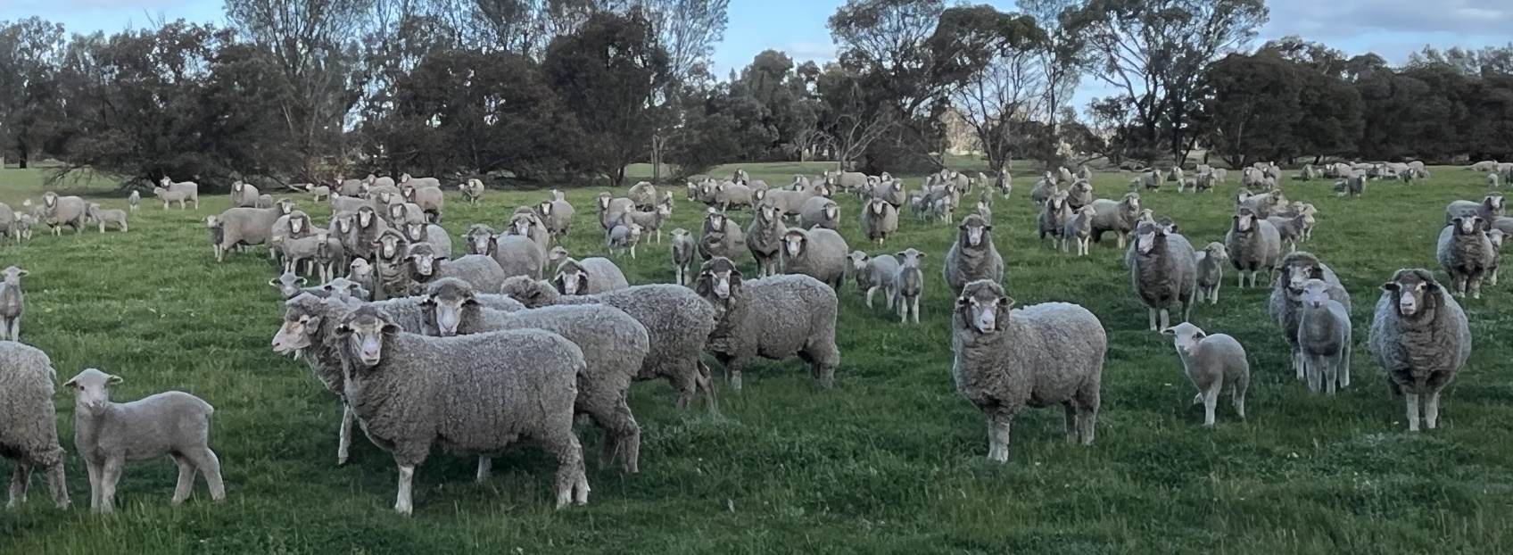

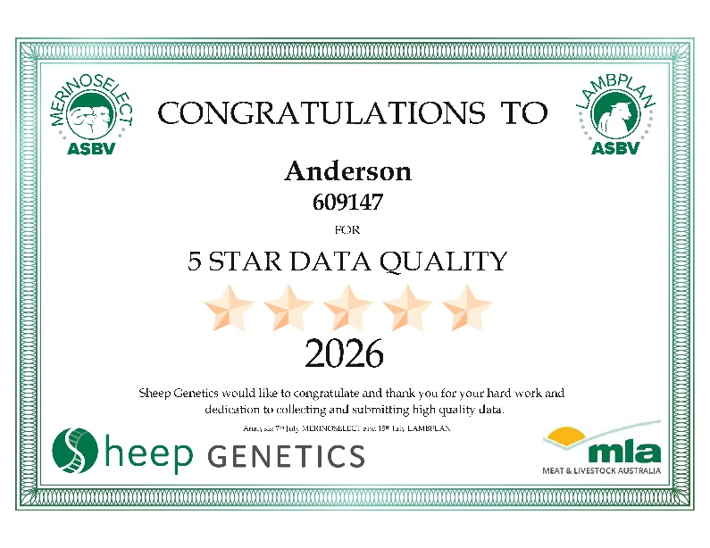

Data Quality

Sheep Genetics assigns each flock a Data Quality Score based on recorded traits, pedigree completeness, linkage and consistency. Anderson’s depth of recording places us among the highest-scoring MERINOSELECT flocks, reinforcing the strength and reliability of our ASBVs.

ASBV Accuracy Matters

Australian Sheep Breeding Values (ASBVs) sit at the heart of high-performing Merino breeding programs. They capture the genetic merit of rams and ewes and create real value when they are accurate, reliable and backed by quality data.
Accuracy is what gives an ASBV its power. It shows how much confidence breeders can place in the figure, reflecting both the depth of information behind it and the reliability of expected progeny performance. A 30–40% ASBV is based on limited data, often the animal’s own record and pedigree. At 70–80%, it draws on multiple traits and relatives’ information. Above 90%, it is supported by substantial records and/or strong genomics, making it highly stable as new data is added. That’s what you get at Anderson.
Accuracy is especially important for complex traits. While simple traits such as bodyweight can provide useful genetic insight from a single measurement, traits such as conception rate, litter size, ewe rearing ability, weaning rate and worm egg count, are more variable and more strongly influenced by the environment.

Accuracy by design
At Anderson, ASBV accuracy is not left to chance. It is built through sustained investment in measurement, disciplined recording and strong genetic linkage. This commitment is reflected in four key areas:
Comprehensive trait recording
Each year, we collect more than 60 data points per stud animal to hogget age, spanning wool quantity and quality, growth and carcase traits, reproduction, worm resistance, dag and breech traits, and conformation scores. Adult fleece records, reproduction results, weights and condition scores contribute to the accuracy of lifetime performance. This breadth of recording strengthens the genetic picture behind every ASBV.
Genomics integrated with phenotypes
Extensive use of 50K high-density genomic test lifts accuracy while keeping ASBVs firmly grounded in real-world data.
Strong genetic linkage
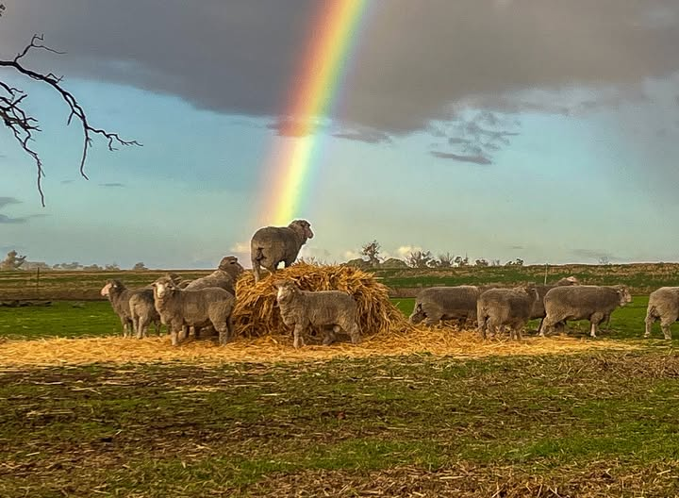
Genetic linkage adds valuable information from relatives and strengthens accuracy across the analysis. Our sires are widely used in Sire Evaluation and other flocks connecting our genetics to the national reference population.
Anderson ASBVs are robust, data-backed selection tools for building productive, resilient and profitable flocks.

Andersons Extensive Influence

Have you ever wondered where Anderson genetics have been used? The answer is: across a wide range of environments and management systems throughout Australia. This exposure to different seasons, locations and production systems provides valuable information on how our genetics perform under varying conditions, helping to increase the accuracy and reliability of our ASBVs.

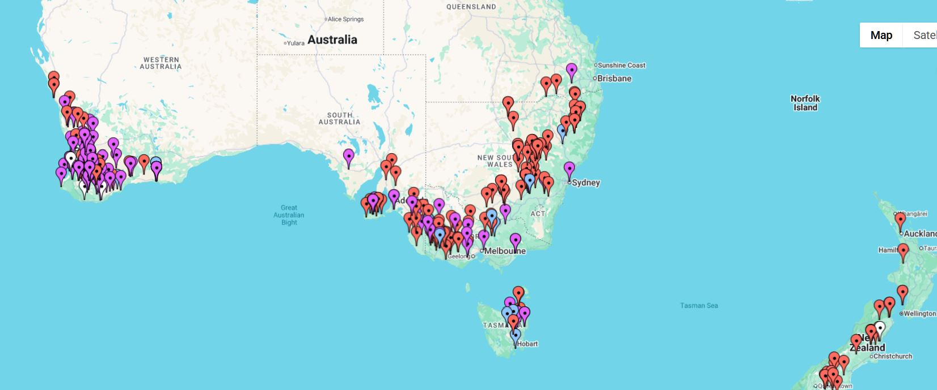

Sire Evaluation Updates

The early results from Yardstick, Katanning WA progeny are out and Anderson 220417 is a trait leader for just about everything measured so far. Check out that outstanding WEC!
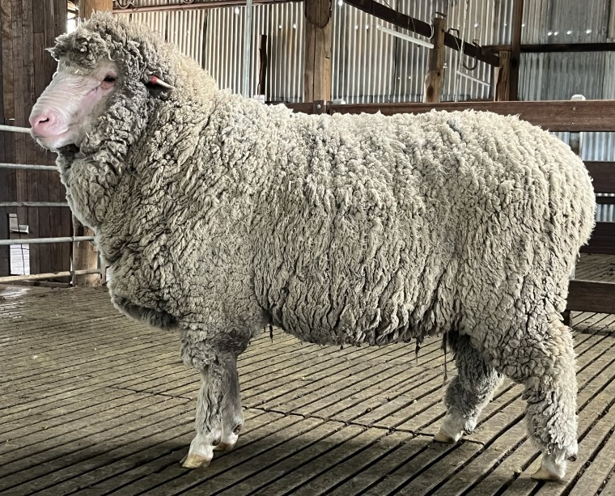
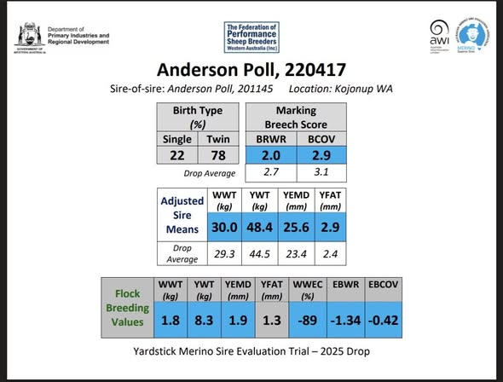
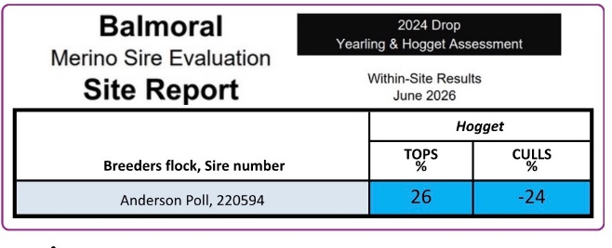

Balmoral, Victoria the visual classers grade for the progeny of both Anderson 200504 (2025 drop yearling age classing) and Anderson 220594 (2024 drop hogget classing) landed both as leaders in their groups for number of tops and culls.

Anderson Poll 140474 – Pingelly MLP Economic Standout
The Pingelly Merino Lifetime Productivity (MLP) results give a rare, independent picture of how different sires turn genetics into profit over a ewe’s whole working life. Anderson Poll 140474 was one of 29 sires evaluated at Ridgefield (Pingelly, WA) under commercial-style management. On the economic measures used in the MLP analysis, his team ranked at the very top.
Most profit per DSE at Pingelly
At Pingelly, each sire team was compared using flock gross margin per DSE under 10-year median wool and meat prices.
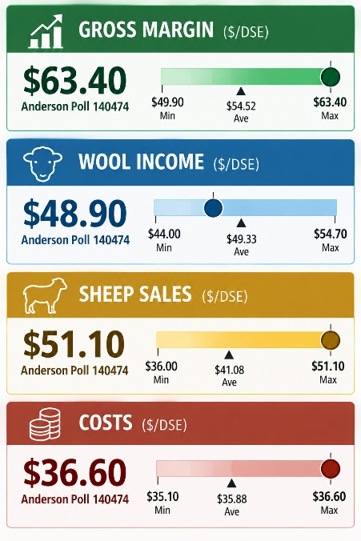
- Across the 29 sires, Anderson Poll 140474 delivered the highest gross margin per DSE, i.e. the most profit per unit of feed under the MLP assumptions.
Anderson leads with key profit drivers
The MLP economic report identified that fleece value and reproduction are the main drivers of profit.
Adult weight, fat depth, staple strength/length and survival are secondary but still important.
Anderson’s Pingelly performance had both:
- High clean fleece weight with a favourable micron
- Very high reproduction and weaning rates hence extra lambs for sale.
This balanced strength in fleece value and reproduction is exactly the trait mix the MLP analysis found in the most profitable sire teams.
The MLP economics were detailed, but they did not put a dollar value on several traits that matter:
- Worm egg count (WEC), breech and body wrinkle, dag and flystrike risk, footrot resistance, intramuscular fat, meat-eating quality, lean meat yield.
For sires with strong WEC, breech wrinkle, dag and eating quality including Anderson, the published gross margins and profit figures are conservative. They underestimate the extra margin likely delivered in low-chemical, non-mulesing or high-welfare systems where these traits reduce costs and risks.

Footrot Flock Breeding Values
Thanks to our clients in NZ who have been able to submit footrot scores, and our participation in the Genetics of Foot Health trial we are now receiving Footrot Flock Breeding Values, and some of the rams in our sale team have a value available. As these values are not ASBVs and do not have an accuracy score they can only be considered in relation to the Anderson flock. However having footrot FBVs is an important step forward for our ram buyers looking for a genetic tool to reduce susceptibility to footrot and for selecting sheep better suited to wet, high-risk environments.

Supporting the Next Generation

The Peter Westblade Scholarship develops the next generation of sheep industry leaders through practical training, mentoring, industry experience and strong connections across the sheep and wool industry.

Anderson Poll Merino is proud to once again support the Peter Westblade Foundation, contributing a portion of the proceeds from a ram sold at our sale.

A complete semen sire list is available on our website and on Merinoselect

Semen Sires

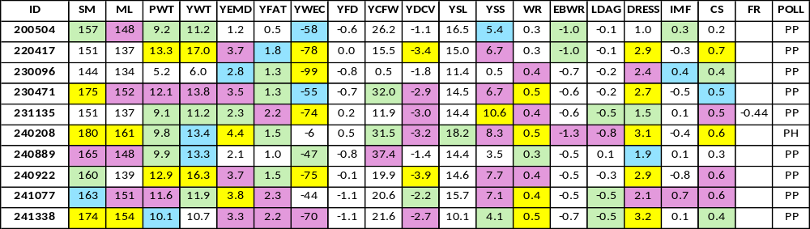

Top  1% | Top  5% | Top  10% | Top  20% | Of values in Merinoselect

And some of our exciting new 2025 drop potential semen sires:

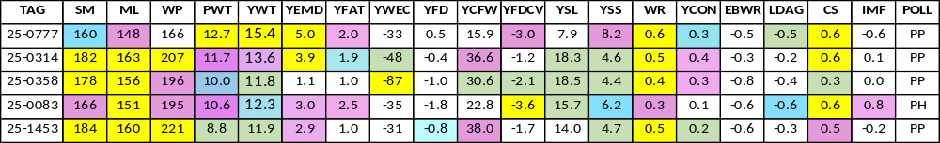
Both young reserves and older semen sires will be on display on Ram Sale day. Contact Lynley if you would like to discuss which of our rams will best suit your breeding objectives.

Get in Touch
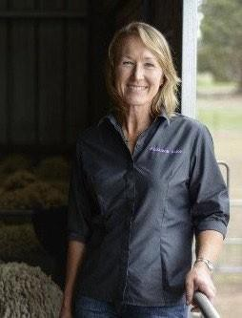
Please feel free to contact me if you would like to discuss our breeding
direction or your ram requirements. Or if you just want to talk all things sheep! Lynley Anderson M: 0429 328 055 E: info@andersonrams.com.au
RMB 512 Kojonup 6395 WA

Genetic Trends
These genetic graphs chart where the Anderson flock sits compared to the average of all animals in MERINOSELECT. Strategic mating of our 1200 stud animals takes many days, incorporating visual traits, ASBV’s, actual measurements and co-ancestry. These graphs show that the time invested rewards all our buyers with continually improved progeny, and the benefits available from annually upgrading your ram team. We are happy to share graphs of any traits.

